**Intro to SE Group Assignment**

**2nd Assignment**

**Sprint 1**



Group members:

**Ahmad Masood(22i-2704), Amar Moosa(22i-2486)**

**Malaika Rehman(22i-2605), Rehab Imtiaz(22i-8769)**

**Class:** SE-E

**Semester: 2**nd

Submitted to:

**Dr. Khubaib Amjad Alam**

**a)** Figma Prototype link:

<https://www.figma.com/proto/4BeaOdpLD2JC55q8ASSY8Q/Intro-Project?node-id=85-635&scaling=scale-down-width&page-id=0%3A1&starting-point-node-id=85%3A635>

Figma design link:

<https://www.figma.com/file/4BeaOdpLD2JC55q8ASSY8Q/Intro-Project?node-id=0%3A1&t=eDoBvJUsCo423Cuj-1>

**b)** GitHub repository link:

[**https://github.com/malaikarehman/Intro-Project**](https://github.com/malaikarehman/Intro-Project)

Screenshot:

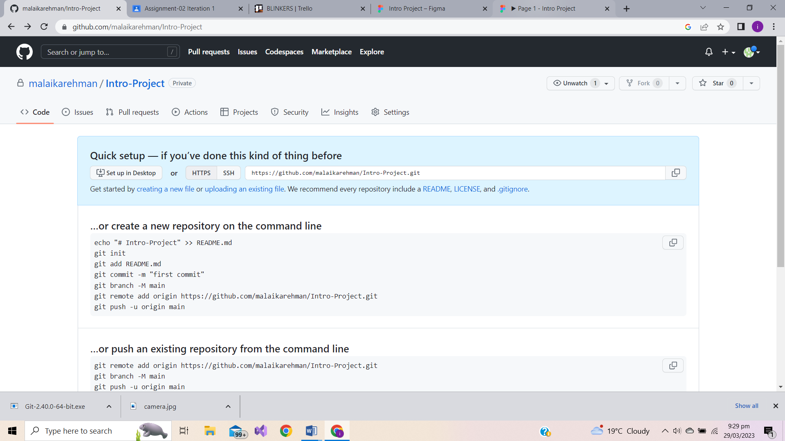

**c)**  **i) Sprint Backlog shows features of product and assigned activities to each member.**

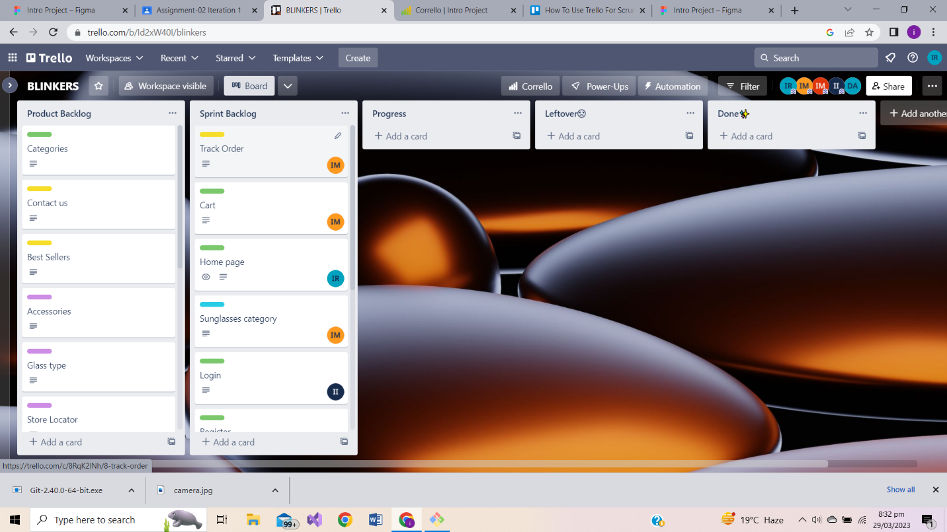

**Half of the feature of 1st sprint are completed by team members.**

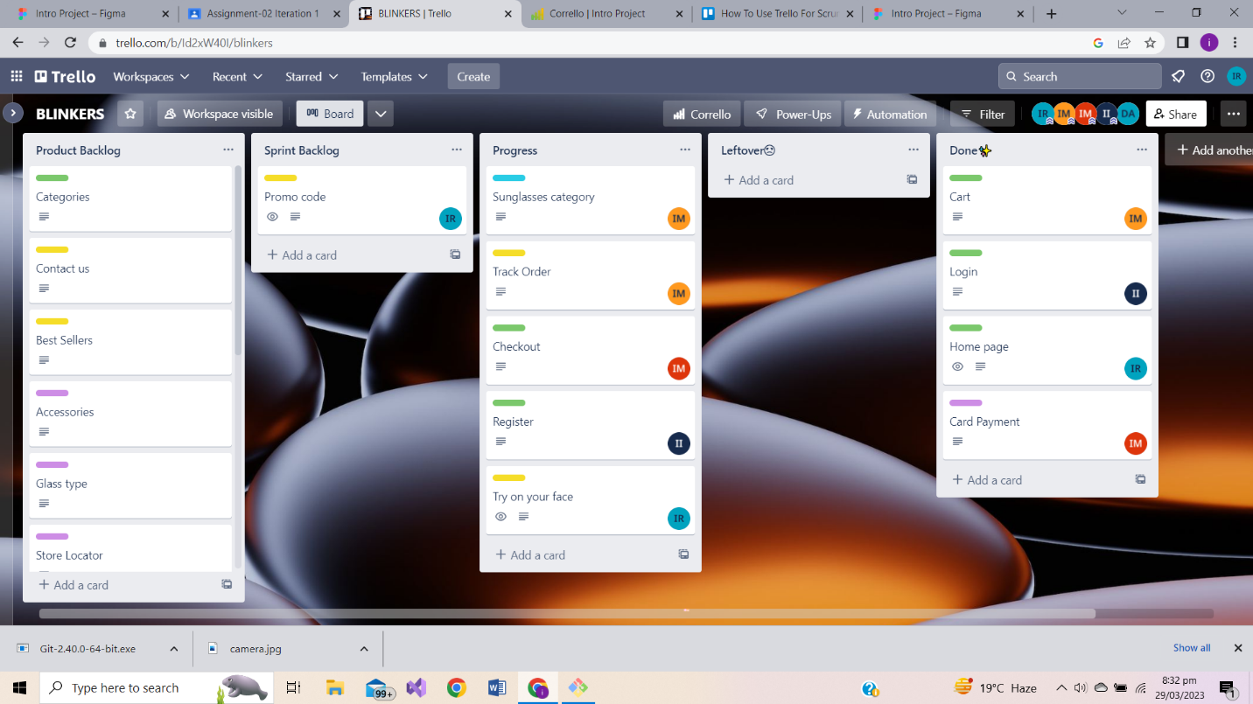

**Work done in 1st Sprint and some leftover features.**

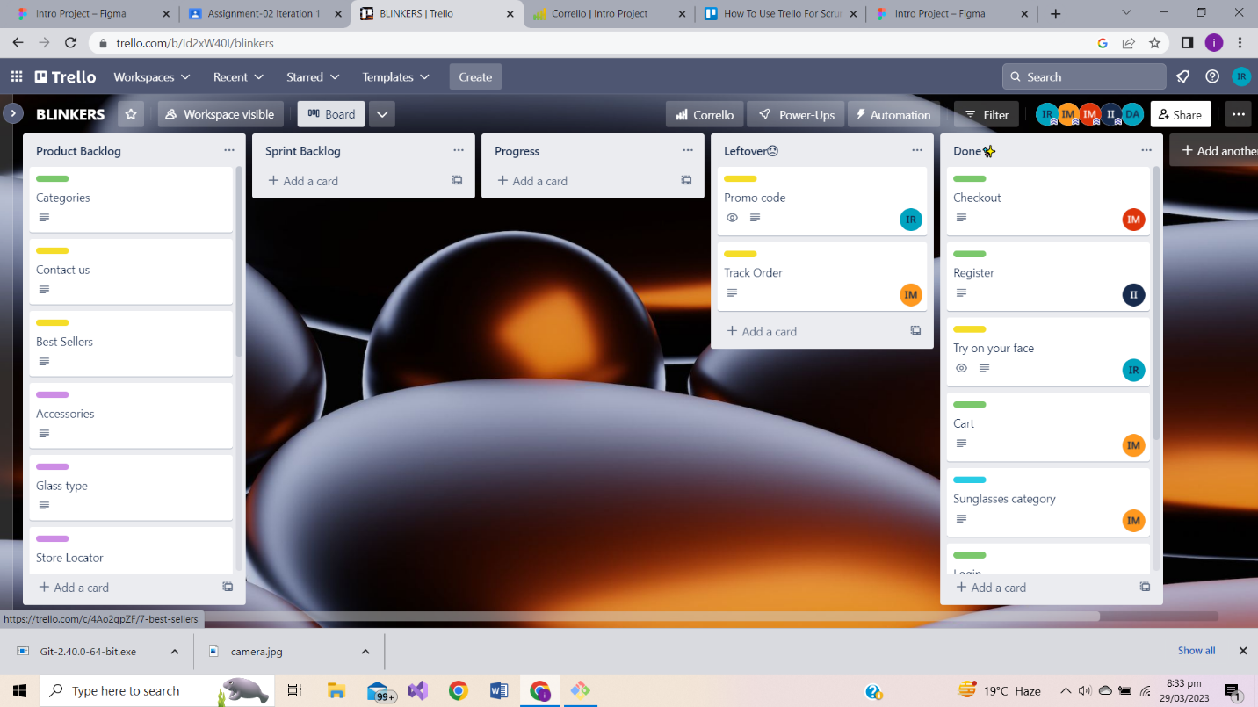

**Activities performed by Scrum Master.**

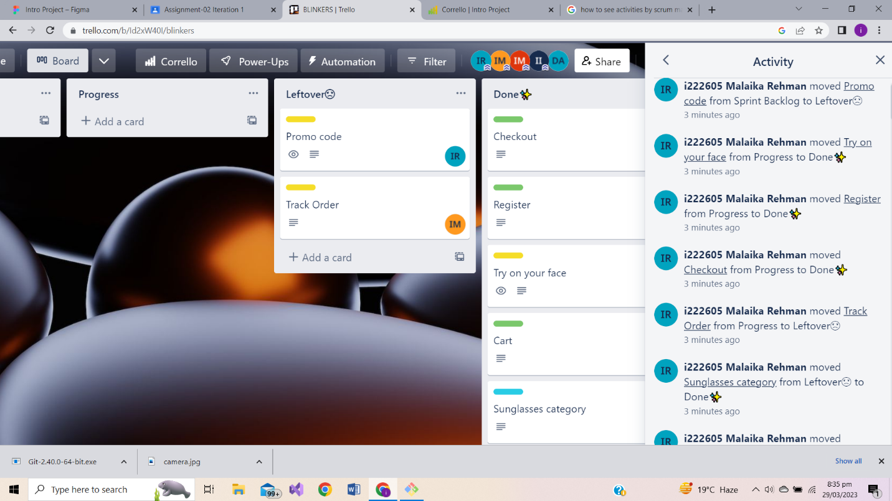

**ii) Leftovers of 1st sprint are now part of second sprint assigned to each member and scheduled(estimated date : 18 April)**

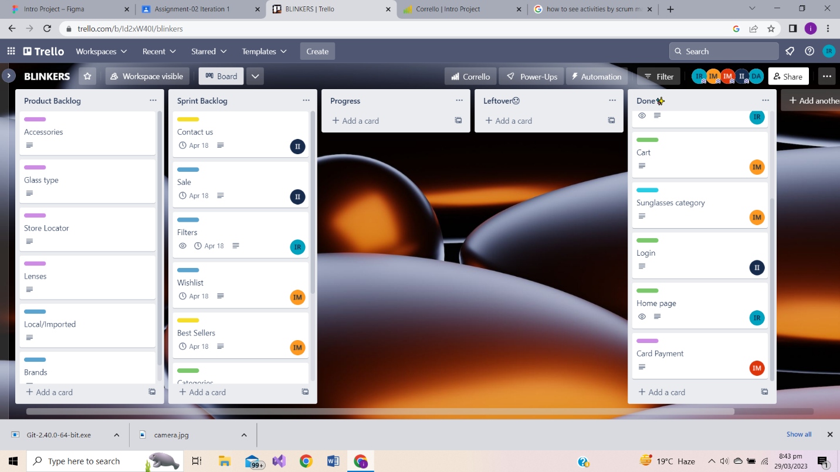

**iii) Sprint burn down chart showing planned versus completed tasks.**

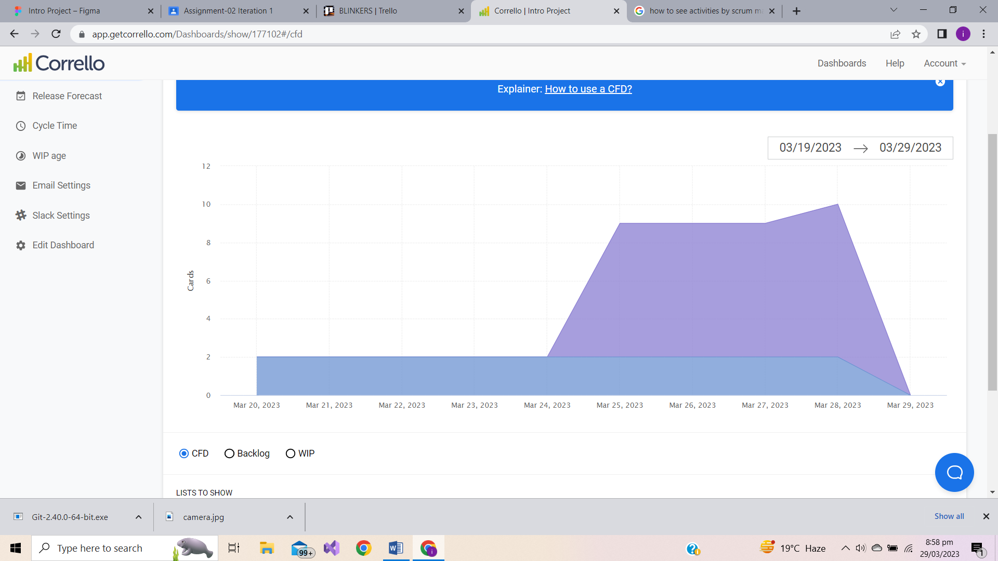

**d) In the next sprint we’ll be working on the following features:**

**1) Track Order**

**Description:**

As a customer,

I want to track my order

so that I know the expecting delivery date.

**2) Contact Us**

**Description:**

As an : optician

I want : my customers to contact me

so that : I can assist them in any query regarding my products.

**3) Sale**

**Description:**

As a : budget-conscious customer

I want to : be able to browse and purchase eyewear that is available on sale, so that : I can get the best value for my money.

**4) Filters**

**Description:**

As a : user

I want to : ease in browsing specific fields, hence the filters

which can help me manage price ranges and glasses type quickly.

**5) Whishlist/Favorites**

**Description:**

As a : user

I want : the website to have a wish list option

where I can add my favorite products,

which can later be bought easily.

**6) Best Sellers**

**Description:**

As a : shopper

I want to : know the best sellers

so that : I can have an idea of current trend.

**7) Categories**

**Description:**

As a : user

I want : a variety of spectacles that can be easily browsed through

so that : I can find perfect pair that matches my preferences.

**8) Promo code**

**Description:**

As a : user

I want : to use promo code

So that : I can save money.

Each task has been assigned to respective team members and an estimated time to complete each tasks.

